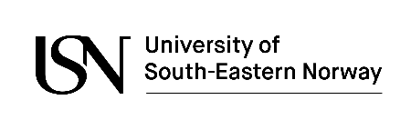

Declaration of consent
related to application for studies at USN

I am responsible for the liability of the uploaded documents, i.e. that they represent true and unaltered information.
I hereby give The University of South-Eastern Norway the right to contact institutions, firms, associations and government agencies for the purpose of explanation and/or verification of uploaded documents.

Name:
Application number:
Date and place:

Remember to sign and upload this document to your application, along with the other documents.

