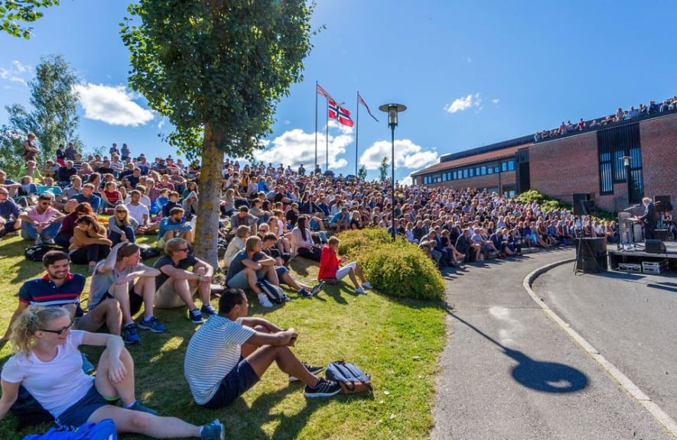
Welcome to USN and to campus Bø!

In this letter you will find important information related to your study program and the coming semester.

We look forward to meeting you!

Congratulations on getting admitted to

Master of Sustainability Management!

Dear student,
It is our pleasure to welcome you to the Master of Sustainability Management program at USN School of Business, Campus Bø. We are also very pleased to welcome you to Bø: Located in the heart of Telemark, Bø is both urban and rural, and offers a wide range of music, sports, and cultural activities.

Congratulations on a great choice!

The semester starts on August 10th 2026, and we have a full program on campus Bø from day 1. The first week of the semester is our introductory week, including both academic and social activities.

Please note that the semesters in this master program are divided in two blocks, with two courses running parallel for half a semester. This means that each course usually run for 7 weeks, with exams after each course. This organisation evens out the workload over the academic year and gives students opportunity to concentrate on the topics and tasks in the programme. Each of our courses contains lectures, tutorials, and seminars on campus, in addition to individual and/or group-based activities engaging the students in the work. We also try to arrange field trips and study visits each semester.

Time schedule
The fall semester 2025 includes the following courses:

Week 34 - 40: MSM 4102 Entrepreneurs, organisations and business models
Week 34 - 40: MSM 4104 Organisation and Leadership - Change Management
Week 41: Exam week
Week 42 - 48: MSM 4101 Sustainable development: politics, law, and institutions
Week 42 - 48: MSM 4103 Green IT and GIS

The detailed time schedule for each course is available in TimeEdit.
To see how TimeEdit works, you can look at this guide.

Opening week
Monday August 10th: Official opening of the semester and information meetings
Tuesday August 11th: Opening seminar: What is sustainability management?
Wednesday August 12th Excursion to the Fen-field; Europes largest deposit of light rare earth minerals which is located only 30 minutes from Bø Campus. A real kick-start and introduction to the many complex issues of sustainability.
Thursday August 13th: Workshop on campus based on the Fen-field case
Friday August 14th: Introduction to fall courses and workshop in academic writing and reading

Each afternoon + night includes social activities on campus led by students.
For a detailed schedule of the opening week, see TimeEdit (available from June 15th).

How to prepare
To make sure that you are well prepared for the coming semester, please check our semester start pages for continuous updates. For more information on campus Bø, check out our campus pages. For housing, contact SSN. You can also connect with us over the summer on social media: On Instagram you will find us at @usn.msm and @campus_bo.

Special needs?
Our students represent a great diversity, and everyone should have the opportunity for equal education.
If you are in need of special facilitations, please look at this guide.

Do you have any questions?
For questions related to the study program, contact program coordinator Anne Gry Gudmundsdotter. For practical matters, contact student advisor Hege Skogli Riege.

We look forward to meeting you, and we hope you have a great summer!

Best regards,

Anne Gry Gudmundsdotter
anne.g.gudmundsdotter@usn.no

Associate Professor and Program Coordinator
USN School of Business
Department of Business and IT

“This program is your key to unlocking the treasure of sustainability in the most meaningful way for you. If offers the opportunity to deeply explore the topics, you are passionate about. So, embark on this journey with enthusiasm, commitment and loads of learning.”
(Noor Jahan Khan, former student at Master of Sustainability Management)



Master of Sustainability Management, study model overview

Fall semester, year 1 (all courses are mandatory)
Week 33: Opening week, see separate program.

Week 34 - 40: MSM 4102 Entrepreneurs, organisations and business models
Week 34 - 40: MSM 4104 Organisation and Leadership - Change Management
Week 41: Exam week

Week 42 - 48: MSM 4101 Sustainable development: politics, law, and institutions
Week 42 - 48: MSM 4103 Green IT and GIS
Exam period

Spring semester, year 1 (all courses are mandatory)
Week 2 - 8: MSM4202 Strategy and Innovation for Sustainability
Week 2 - 8: MSM4203 Sustainability marketing
Week 9: Exam week

Week 10 - 17: MSM4201 Sustainability Finance
Week 10 - 17: MSM4204 Methodology and research design
Exam period

Fall semester, year 2 (method courses + elective courses)
Week 34 - 48: MSM4330 Spatial analyses
Week 34 - 48: MSM4340 Academic engagement
Week 34 - 40: MSM4301 Qualitative research
Week 34 - 40: MSM4302 Quantitative research methods
Week 41: Exam week

Week 42 - 48: MSM4310 Alternative Economy and Local Resilience
Week 42 - 48: MSM4320 Nature, culture, and experiences
Exam period

Spring semester, year 2
MSM 5000 MA thesis: Writing of thesis + seminars throughout the semester.

